***Kedarkantha Trek 2020-2021***

**Valid Till 31st March 2024**

**The Prominent winter trek in Garhwal Himalayas. Uttarakhand INDIA**

Kedarkantha is perched at an altitude of 3,800 m in Uttarakhand. And, the Kedarkantha trek offers 6 days sojourn with the taste of perfect adventure and jaw dropping experiences. Arguably, Kedarkantha trek is the prominent winter trek! It has got unmatched beauty in winters. The trail hides in thick blanket of snow. The lush verdant forests turns white making it a small wonderland! The Kedarkantha trek is not only for experienced trekkers but for amateurs and children too!

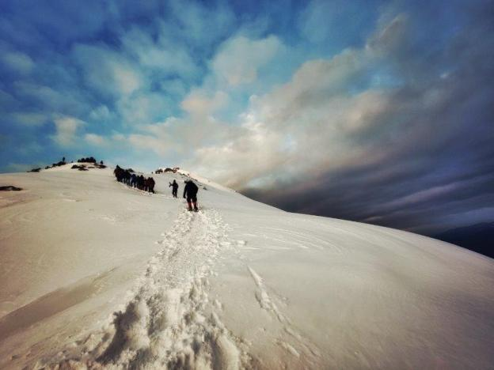

**Altitudes:**

Sankri (1920 meters), JudaKaTalab (2700 meters), Kedarkantha base camp (3400 meters), Kedarkantha summit (3800 meters)

**Kedarkantha trek**

Summer Temperature: Day (5°C to 15°C) Night (2° C to 5° C)

Winter Temperature: Day (-2°C to -5° C) Night (-5°C to -10°C)

Kedarkantha Altitude: 3800 Meters

Trek Level: Moderate

Trek distance: On foot 23 Kms

**Short Itinerary Kedarkantha Trek**

**Day 1: Dehradun to Sankri (190 Kms / 7-8 Hours drive) (1920 Meters Altitude)**

Morning 07 AM pick up from Dehradun Railway Station. Transfer to Sankri. On the way stop at Mussoorie Kempty Falls. Enjoy Yamuna river view later on the way. At arrival check in to hotel in Sankri. You will be given details about next day schedule and instructions. Later you can walk around or relax. Overnight stay at hotel in Sankri. (Dinner included)

**Day 2: Sankri to Juda Ka Talab (05 Kms Trek) (4/5 Hours) (2700 Meters Altitude)**

Today after breakfast, we will start our trek around 8 AM. You will see some small Himalayan villages, natural streams of water falling from mountains and forest. Our destination today is Juda Ka Talab which is 100 meter long and 35 meter wide lake. Later enjoy nature around or relax. Overnight stay in camps. (All meals included)

**Day 3: Juda Ka Talab to Kedarkantha Base Camp (3.5 Kms trek / 3 hours)** **(3200 Meters Altitude)**

Today after breakfast, we will start our trek around 8 AM. Sometimes the night time snowfall changes the views suddenly. Today we will trek to Kedarkantha Base camp. Here Kedarkantha mountain is visible clearly. After lunch enjoy nature around or relax. Next day we will start early so plan accordingly. Overnight stay in camps. (All meals included)

**Day 4: Kedarkantha Base Camp to Kedarkantha Summit (3800 meters Altitude) and return to Har Gaon (9 Kms Trek / 5 -6 3 hours)** **(2700 Meters Altitude)**

Today we will start early for the sunrise view. We will start at 4:30 AM for sunrise view. Light breakfast will be provided. It’s little steep climb but it’s worth. Sunrise views in mountains are mesmerizing from the altitude of 3800 meters. (If weather is clear). Enjoy breathtaking views of Himalayas. Take blessing from Shiva Temple here. While returning sliding on safer slopes can be great fun. Later return to base. After lunch relax or enjoy nature around. Overnight stay in camps. (All meals included)

**Day 5: Har Gaon to Sankri (5.5 Kms Trek / 4 hours)** **(1920 Meters Altitude)**

Today after breakfast, we will start our trek around 9 AM. After spending good amount of time in mountains, today’s descent will be easier for you. You will see some Apple Orchards here on the way along with villages. Overnight stay at hotel in Sankri. (All meals included)

**Day 6: Sankri to Dehradun Drop (190 kms / 07-08 Hours).**

Morning after breakfast, check out from hotel. Transfer to Dehradun. Drop at Dehradun Railway Station (Breakfast included)

|  |
| --- |
| **INR 6700/- Per Person Triple Sharing / Qaud Sharing** |
| **INR 8400/- Per Person Double Sharing** |
| **GST 5% Extra** |

**Package Cost Includes:**

* 02 Nights accommodation in hotel in Sankri Hotel.
* 03 Nights stay in high quality tents.
* All meals as mentioned above from day 01 dinner till day 05 breakfast (Indian Vegetarian meals with Eggs sometimes).
* Transportation by Tempo Traveler from Dehradun.
* Dining Tent & Toilet Tent.
* Professional and experienced Trekking Tour Leader and Support Staff.
* Clean and sanitized sleeping bags & Mattress.
* Trekking equipments for group (Gaiters, Crampons if required as per the trek and weather).
* Porters & Mules (For Camping equipment and kitchen stuff).
* Forest Permit and entrance fee. (Included for domestic clients)
* First Aid Medical Kit, Oxygen Cylinder for emergency.
* During trek we serve three meals a day including snacks and soup. A variety of delicious and healthy food is provided including local ingredients. They are nutritious and keep you fit and healthy on the trek.

***Excludes:***

* Personal expenses like tips, personal medicines, phone calls etc.
* Any transport support during the trek apart from what is included above.
* Any cost or services not mentioned in the Inclusions.
* Cost arising due to unforeseen incidents like bad weather, medical evacuation, road blocks etc.
* Porter/mule charges to carry personal luggage. Can be arranged at an additional cost of INR 300 per day (1 soft bag per person < 12 kg).
* Rent for walking poles: INR 50 per pole per day, Rent for trekking shoes: INR 200 per pair per day

***Cancellation Policy:***

* Full refund if cancelled more than 21 days before.
* No refund for cancellation Less than 20 Days – No Refund.
* In the case of cancellation of trek from our side due to bad weather or similar situations beyond our control refund would be difficult if the trek is cancelled midway. If it’s cancelled before starting trekking than we will provide alternate options for the trek same time or with different dates instead of the refund.

**Why Us:**

Professionally trained and experienced guide well versed with area and local flora, fauna and culture.

100 % Guaranteed departure regardless of group size.

Best in class guide to trekker ratio.

High quality tents used in trek specially made for higher altitude and different weather situations according to trek area.

Good quality, clean & sanitized sleeping bags for each tour.

Specially designed food menu for each day for health & nutritious.

Clean, well maintained and sanitized transportation.

Well managed treks for minimum impact for nature.

**ATM Point and Mobile Connectivity info**

**ATM POINT:** Withdraw money before your journey, Purola is the last point where you will find ATM. However it due to remote area it may have sometime issues so better to use ATM in Dehradun / Mussoorie.

**Mobile Connectivity:** There will be no networks during the trek, in Purolayour device will receive the networks and at Sankri only Vodafone and BSNL signals are there but you cannot rely on the connectivity because the signal strength is not good. So make sure you finish all your important work and calls before starting of the trek.

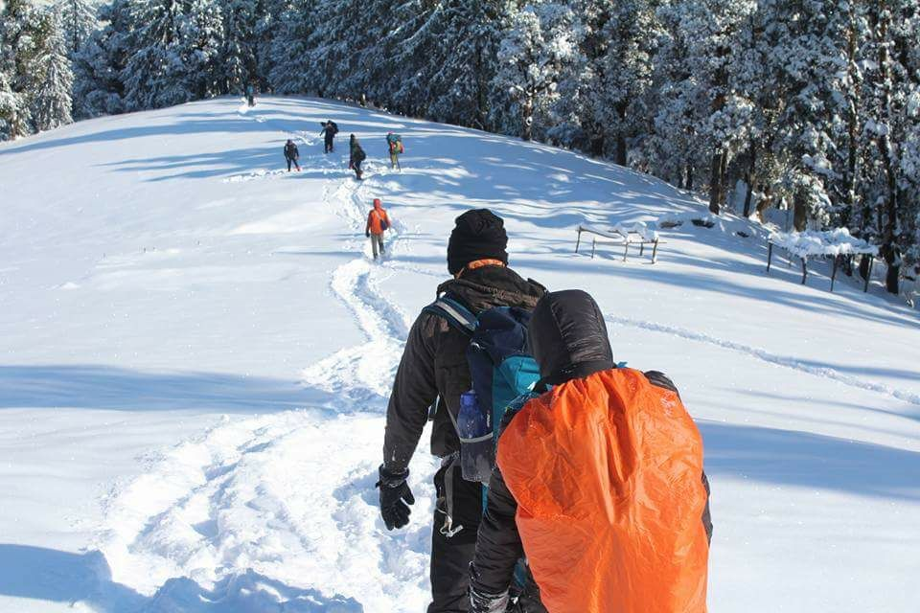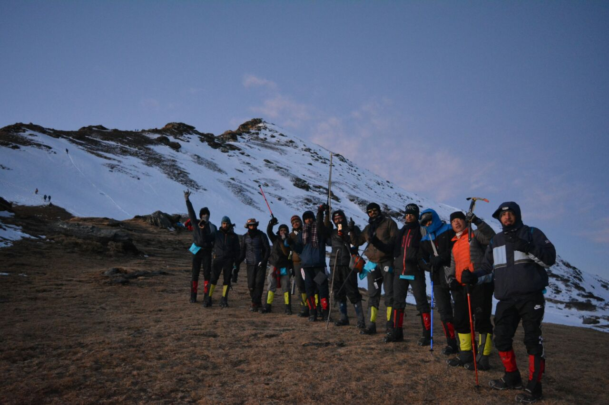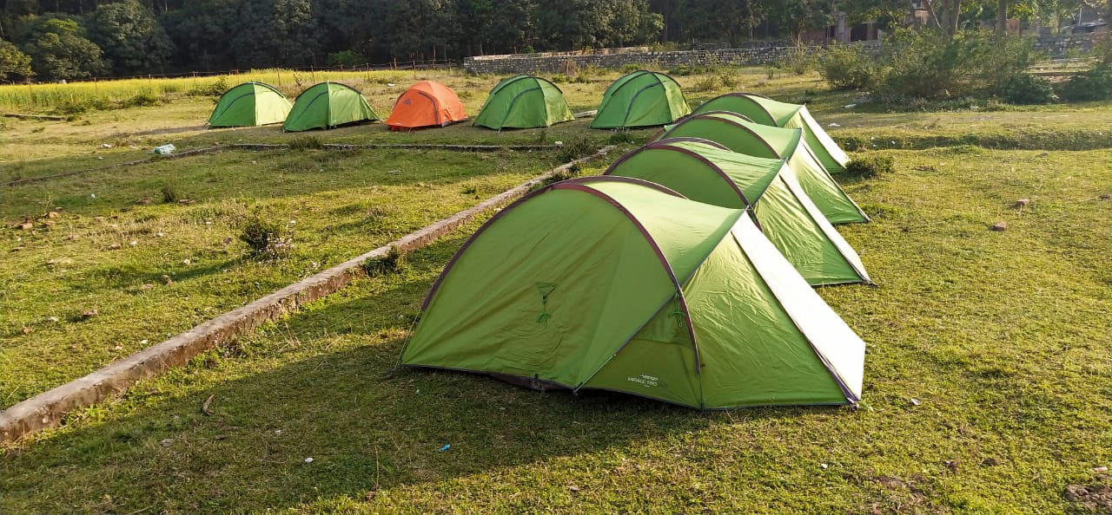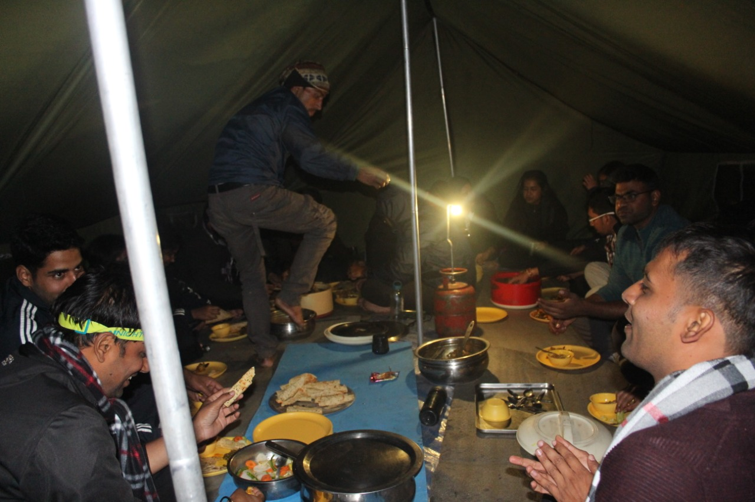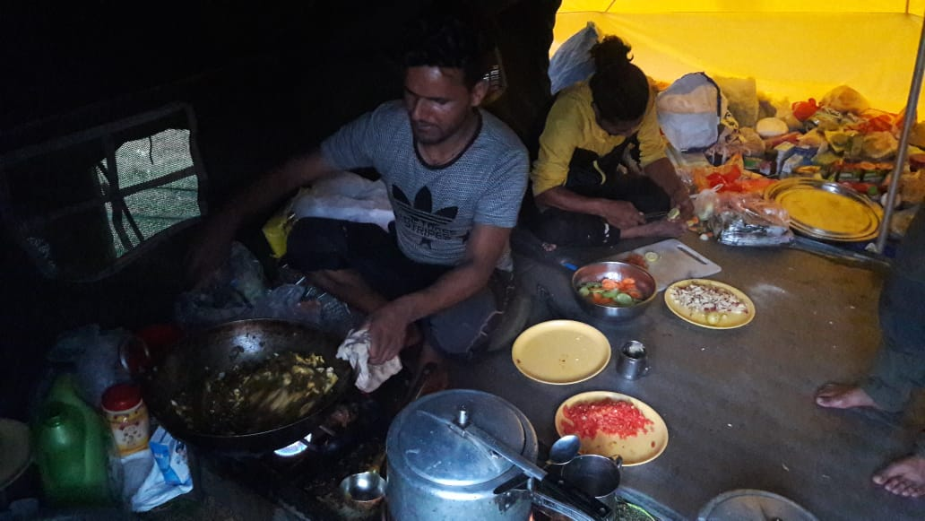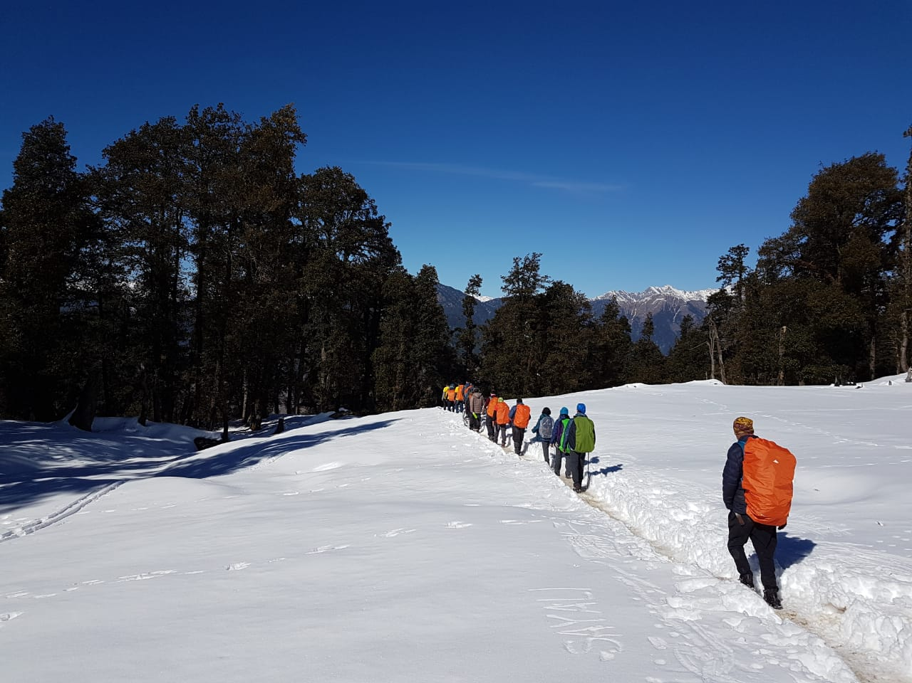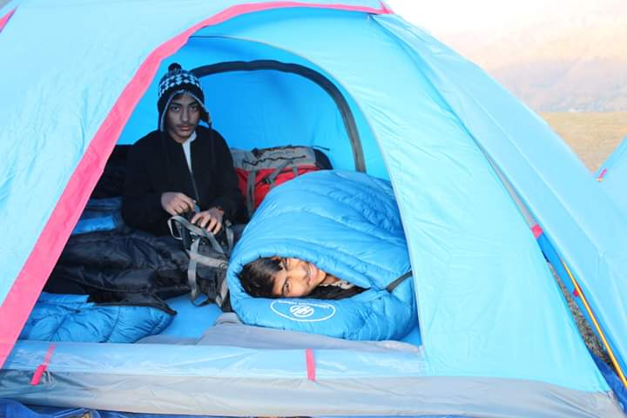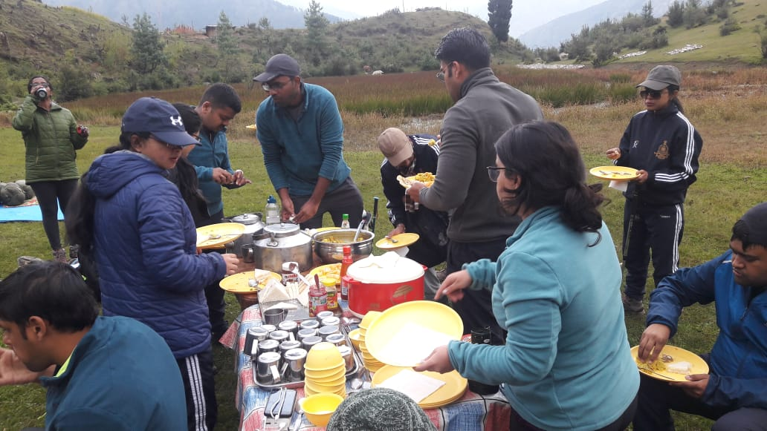

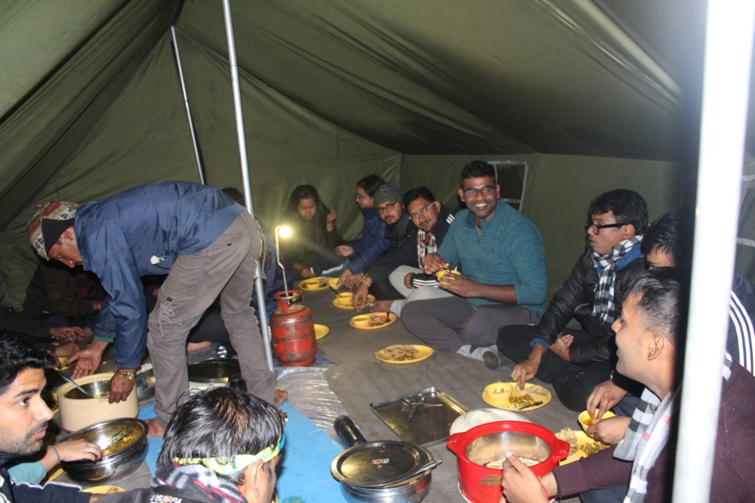

|  |  |  |
| --- | --- | --- |
| **Trekking Essentials** | | |
| Trekking shoes: High ankle, thick sole with good grip; preferably waterproof | Waterproof rucksack or rucksack with rain-cover | Governement issued photo identitiy cards |
| **Clothes** | | |
| Raincoat/ poncho | Wind & waterproof pant | 2-3 trousers (avoid shorts, fitting denims, capris) |
| Windproof jacket | 3-4 T-shirts/shirts; Preferably quick dry | Warm fleece, alternative; a woolen sweater |
| Extra pair of socks | 1 small towel | Balaclava |
| **Add-ons on for winter** | | |
| 1 pair of woolen socks | 1 pair of thermal inner wear (Upper and lower) | Waterproof thick gloves |
| **Accessories** | | |
| Water bottle (Kindly do NOT carry Bisleri bottles) | Sunscreen cream/moisturizer/lip balm | Head Torch (hand torch would be an alternative) |
| Slippers / sandals; non-slippery | Sunglasses (it should be UV protected) or use Photo chromatic glasses. | Camera (Optional) |
| Hat or sun protection cap | Dry tissues (Wet tissues are not encouraged as they NOT bio-degradable) | Towel |
| Woolen cap/scarf | Hot water bags | Personal medical kit |
| Polyethene bags to store soiled clothes / trash | Sunscreen cream/moisturizer/lip balm | Power bank to charge mobiles |
| **Personal toileteries** | | |
| Hand sanitizer | Dry tissues (Wet tissues are not encouraged as they NOT bio-degradable) | Towel |
| Toilet paper roll | Toothbrush/toothpaste | 1 small box of soap/body wash/facewash |
| **Personal medical kit** | | |
| Diamox - to prevent AMS | Norflox TZ & Lomofen - (diarrhea) | Cotton - 1 small roll |
| Crocin - fever | ORS | Betadine or any antiseptic cream |
| Avomine - (motion sickness) | Omez/ Rantadine - (antacids) | Moov/volini spray (aches, & sprains) |
| Avil 25mg - (allergies) | Crepe bandage - 3 to 5 meters | Knee caps |
| Combiflam - (Pain killer) | Gauze - 1 small roll | **Personal medications, if any** |
| Disprin - (headache) | Band aids - different sizes | Digene - (acidity) |