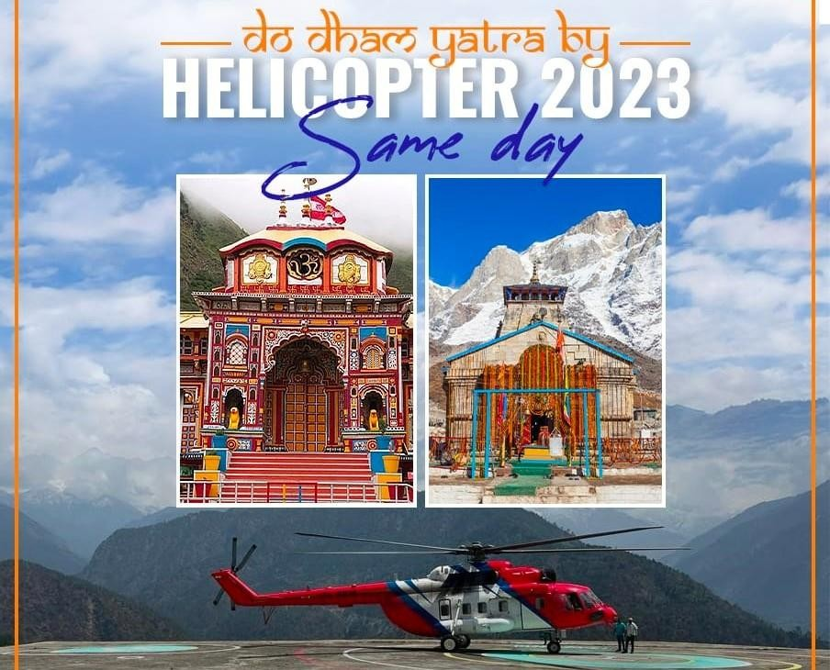

Do Dham Yatra Same Day By Helicopter Jai Badri Vishal Jai Shri Kedar

**The package is inclusive of:**

* Helicopter trip from Sahastradhara Helipad, Dehradun
* Lunch
* VIP Darshan at Kedarnath Ji & Badrinath Ji
* Dedicated staff at both places for all coordination and

Comfortable Darshan.

* Vehicle at Badrinath.
* All applicable Taxes.
* Royalty Fees & GST .

The itinerary is as follows; Below timings are tentative & subject to flying operations & weather conditions:

|  |  |  |
| --- | --- | --- |
|  | **Kedar-Badri Do Dham**  **Itinerary** |  |
| **Start Time**  **\*** | **End Tim**  **e** | **Details** |
| 0630 | 0730 | Dehradun  (Sahastradhara Helipad) to Badrinath By Helicopter |
| 0730 | 0830 | VIP Darshan at Badrinath Ji |
| 0900 | 0930 | Badrinath to Guptkashi |
| 0930 | 1330 | Guptkashi – Kedarnath  Darshan |
| 1400 | 1440 | Guptkashi to Jolly Grant Airport, Dehradun  (Sahastradhara Helipad) |

# Special Rates INR 1,00, 000/- Per person

**Please refer the important details:**

* Trip is subject to COVID-19 travel guidelines by competent authorities at thetime of departure.

# For darshan at both temple registration is required. https://registrationandtouristcare.uk.gov.in/signin.php

* **Average body weight 75 Kg per person.**

# Luggage allowed 2 Kg per person.

* The time may change in case of bad weather or the scheduling of helicopters.
* In case of any stay is required at any destination due to bad weather or any unforeseen reasons it will be borne by the

guest directly.

* Passengers should carry only handbags as suitcases cannot be kept in the helicopter
* All temples in Char dham are located in high altitude areas. Passengers are advice to carry regular medical kit.
* All passengers undertaking this Yatra should be medically and physically fit.
* Passengers are advised to carry a small oxygen bottle with them as a precaution. It is available locally at all medical shops.
* Although day temperatures at these locations are normal it becomes cold in the night and so passengers must carry woollen clothes with them.
* Children above the age of 2 years will be considered full ticket
* There is no provision of concession to children or senior citizens
* In case the journey is not finished within the stipulated time and passengers are not able to visit one or more Dhams due to bad weather conditions/technical reasons then the company will try to visit all places within the stipulated time. Although if this is not possible then the liability of the company will be limited to refund of unutilized sector/s.
* Rescheduling of booking to a next date will be done subject to availability and on payment of 10% of the cost. This will be permitted only if applied 7 days before journey date. In case the rescheduling is requested with less than 7 days to the journey then booking will be treated as cancelled and a fresh booking will be given subject to availability.

The Company reserves the right, without assigning any reason, to cancel, advance, reschedule, over-fly or delay the commencement or continuance of the flight. Without incurring any liability in damages or otherwise to the passengers or any other person on any ground whatsoever. The Company reserves the right to refuse to carry any person whom it considers unfit for travel or what in the opinion of the company may constitute risk to the aircraft or to the persons on board.

# 5% service charge will be applicable in Case of cancellation due to weather or any reason.

If passengers wish to cancel their booking, then they will have to pay following cancellation charges.

# Up to 10 days before journey 30% of amount

* **Up to 05 days before journey 50% of amount**

# Less than 48 hours before journey 75% of amount

* **Less than 24 hours before journey -NO REFUND**

**Note: -**

* Exact Schedule can be advised before a day of departure. Above mentioned schedule is tentative just for understanding the operational system & timing. Things can be changed last moment due to any operational or weather changes.
* **Package Confirmation & Booking, please deposit** the 50 % amount of the Tour cost to process the booking and the balance amount is to be paid 14 days before from your departure dates.

# We sincerely hope the above information is in order and as per your requirement. In case if you need any further information or clarification. Please feel free to get in touch with us.