# Valley of flowers Trek

Valley of Flowers is located in Chamoli district in the state of Uttarakhand India. A UNESCO World heritages site embedded deep within the Himalayan peaks of Uttarakhand, it was discovered in 1931 by a British Treveller frank Smith when he was heading to mount Kamet , Valley of Flowers is a vibrant and splendid national park reposing in West Himalayas. Nestled in Uttarakhand, this alluring place is famous for its charming meadows of alpine flowers. Endowed with a diverse range of endemic flora, it is picturesque in its beauty. This lush region is also home to some rare and endangered animal species. You may spot animals like Asiatic black deer, snow leopard, musk deer, red fox, brown bear and blue sheep. High in the lofty Himalayas of the Garhwal region sprawls this enchanting valley. Legends believe it to be the place from where Hanuman had collected the Sanjeevani buti for curing Lakshman. This place has floral pastures, running streams and beautiful backdrop of the mountains.

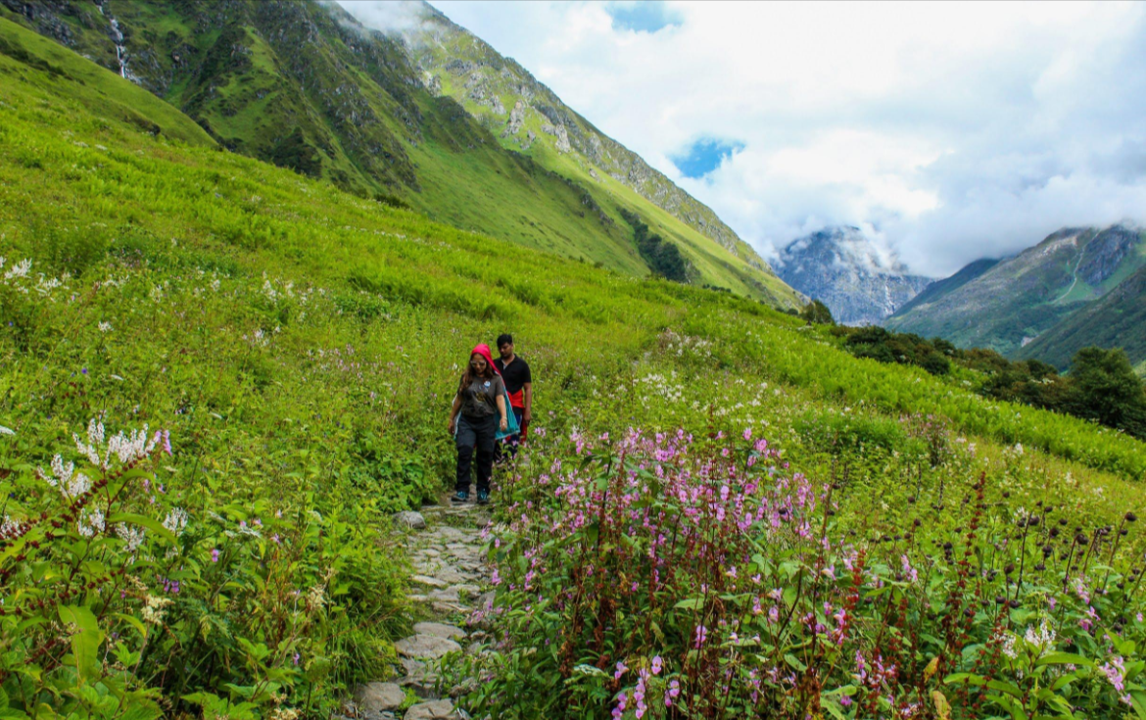

**Valley of Flowers Tour Overview**

**Duration:** 06 Days

**Pick up and drop:** Haridwar / Rishikesh.

**Best Time to Visit:** July to Middle of September

**Trekking Level:** Easy

**Trekking Distance to Cover:** 32 Kms Approx

**Weather:** Due to monsoon season you might experience rain often. Daytime weather can be little humid. Weather is pleasant in daytime and night time can be little cold.

## 

## Itinerary Valley of flowers

**Day 01: Rishikesh / Haridwar to Govindghat (270 Kms / 8 Hours) 1830 Meters Height**

Morning meet our representative at your Hotel / Railway Station. After some basic information start your journey to Govindghat. On the way visit Devprayag & Rudraprayag. Check in to hotel. Dinner and stay in hotel. (Dinner)

**Rudraprayag:** It is one of the PanchPrayag (five confluences) of Alaknanda River. It is confluence of rivers Alaknanda and Mandakini. Kedarnath, a Hindu holy town is located 86 km from Rudraprayag.

**Dev Prayag:** One of the most famous out of Panch Prayag Devprayag is where Alaknanda River (From Badrinath) & Bhagirathi River (coming from Gaumukh) meets each other. Together they are called The Ganga.

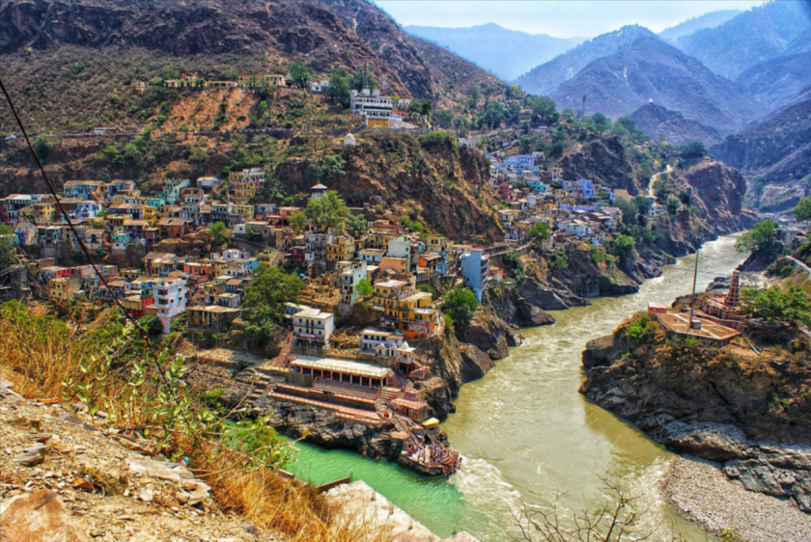

**Devprayag**

**Day 02: Govind Ghat  Ghangharia (14 kms trek) 3050 Meters Height**

Morning after breakfast, check out from hotel. Transfer to Govindghat. Later start your trek to Ghangharia. Check in to hotel at arrival. Dinner and stay at hotel.

Now local jeep is available for first 04 kms (Govindghat to Pulna) 50 Rs Person approx. Pulna to Ghangharia is 11 Kms trek. Horse is also available at own cost.

**Ghangharia Village:** Small village in Bhyundar Valley. Mostly active during the monsoon season when tourist visit Valley of Flowers / Hemkund. It is surrounded by natural beauty of mountains.

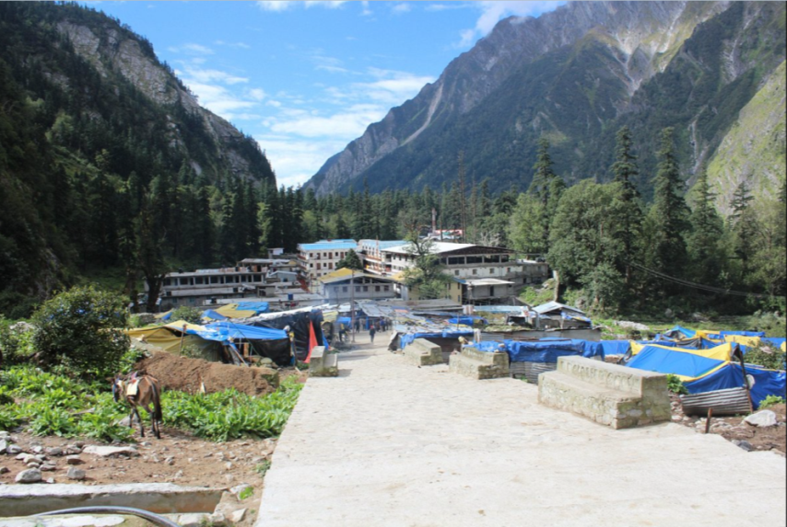

**Ghangharia Village**

**Day 03: Ghangharia  Valley of flowers  Ghangharia (5 kms trek one way) 3600 Meters**

Morning after breakfast start your trek to Valley of flowers. Enjoy valley of flowers visit. Later return to hotel in Ghangharia. Dinner and Overnight at Ghangharia.

**Valley of Flowers:** Considered one of the most beautiful places in the India. The valley remains covered in snow most part of the year. After the snow is melted in summer open land is covered by variety of flowers for 02-03 months (July to Sep).

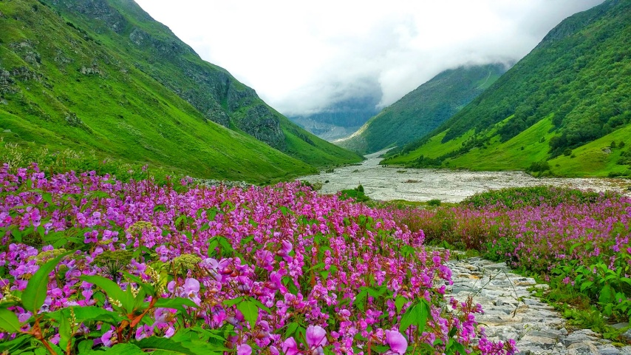

**Pushpawati River at Valley of Flowers**

**Day 04: Ghangharia  Hemkund Sahib  Ghangharia (5 kms trek one way) 3600 Meters**

Morning after breakfast, start your trek to Hemkund Sahib. Visit Hemkund Sahib and Small Lake near it. Later return to hotel in Ghangharia. Dinner and Overnight at Ghangharia. **(Breakfast & Dinner)**

**Hemkund:** One of the Highest located Gurudwara in the world. Dedicated to Guru Govind Singh. It is especially popular among the Sikh Religion pilgrims. Small Lakshman Temple is also close to the Lake.

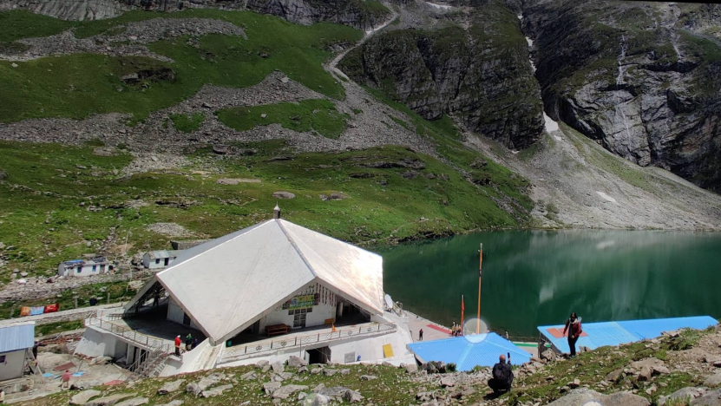

**Day 05: Ghangharia  Govindghat (14 kms trek).**

Morning after breakfast, check out from hotel. Start your trek to Govindghat. Drive to your hotel. Check in to hotel in Govindghat. Dinner and Overnight stay at hotel.

Now local jeep is available for last 04 kms (Pulna to Govindghat) 50 Rs Person approx. Ghangharia to Pulna is 11 Kms trek. Horse is also available at own cost.

**Day 06: Govindghat to Rishikesh / Haridwar (270 kms / 8 hrs drive)**

Morning after breakfast, check out from hotel. Transfer to Rishikesh. Visit Narsingh Temple and Shankaracharya Math in Joshimath. Visit Karnprayag and Nand Prayag enroute.

**Joshimath:** is situated on the slopes above the confluence of the rivers Alaknanda and Dhauliganga. One Of the four 'Maths' established by AdiShankaracharya, Joshimath is the winter seat of Badrinath. The idol is brought down to Joshimath and installed in the temple for people to worship. There are many other temples in the township. The most important is the temple of Nar Singh with the idol of Lord Vishnu.

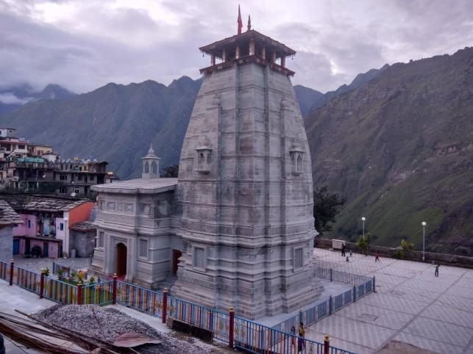

Drop at Rishikesh - Haridwar Hotel / railway station.

|  |
| --- |
| **Package Cost Per Person** |
| **INR 11,199 Per Person Triple / Qaud Sharing** |
| **INR 12,299 Per Person Double Sharing** |
| **All inclusive without hidden charges.** |
| **Fix Departure each Saturday (July & Aug Only)** |
| **\*Standard Tour Suitable for Youngsters** |

## Package Cost Includes:

* Transport from Haridwar / Rishikesh. (Sumo / Tempo Traveller as per Group Size)
* 05 Nights Accommodation in hotels Double / Triple / Four Sharing.
* All meals: 05 Breakfast 04 Lunch & 05 Dinner.
* Guide during the trekking.
* Forest Permit and entrance fee.
* GST 5%

|  |  |  |
| --- | --- | --- |
| Hotels | | |
| Govind Ghat | 02 Nights | Standard Hotel / Homestay / Camp |
| Ghangharia | 03 Nights | Standard Hotel / Homestay / Camp |

# Package Cost Excludes:

* Extra meals.
* Personal Insurance.
* Personal toiletry Items.
* Personal Luggage Porter Costs.
* Personal use medical items.
* Anything not mentioned in including.

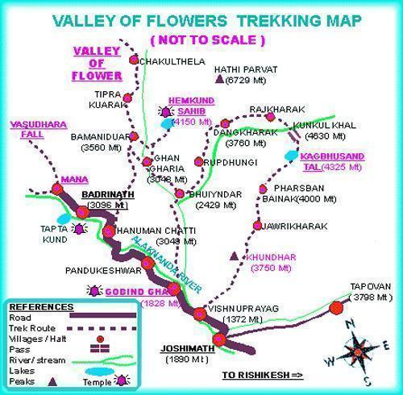

***Things to Carry on a Trek***

*.*