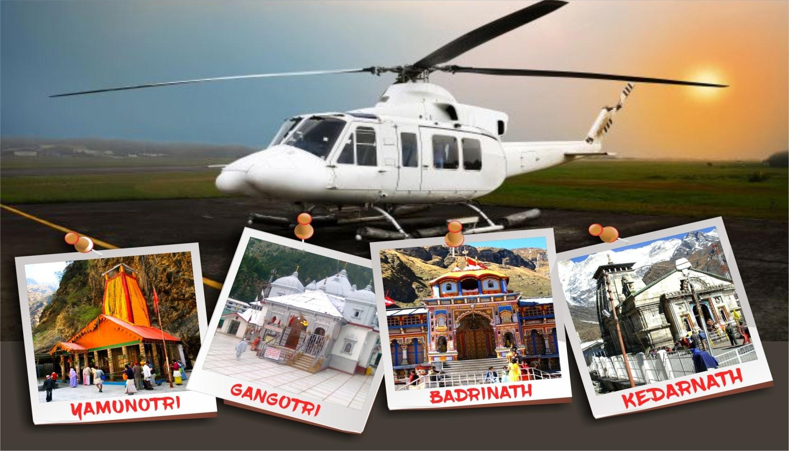

CHARDHAM YATRA BY HELICOPTER EX-DEHRADUN 05N/06D *–*2024

# Places covered- | Yamunotri | Gangotri | Kedarnath |Badrinath

**Yamunotri:** The First Chardham (Going From Left To Right, As Is Traditionally Stipulated), Is One of the Most Revered Temples in India. Yamunotri Is The Source Of The Sacred River Yamuna That Originates From The Glacial Lake Of Saptarishi kund, At an Altitude of 4,421 Meters. Dedicated To Capricious Goddess Yamuna, This Ancient Temple Has Been A Pilgrimage For Centuries. Starting At Rishikesh, The Yatra Takes The Pilgrim Through Some Of The Most Beautiful Panoramas, And Eventually, On The 14 Kilometer Arduous Trek From Hanuman Chatti That Is Not Merely Visually And Physically Stimulating But Spiritually Uplifting.

**Gangotri:** Ganga, India’s Most Sacred River Is Inextricably Linked to Our Past, Present, And Future; It Is The Very Essence Of Our Cycle Of Life And Death. The Journey To Its Source Is To Reinforce Those Systems Of Belief That Have Been Held Sacred By Our Ancestors For Centuries. The Pilgrimage Begins At Rishikesh, An Ancient Holy Town, And Leads The Traveler Through Majestic Vistas, Stunning Valleys, And Beautiful Meadows To Eventually End At The Holy Temple Of Gangotri. All Through The Journey, It Is The Glimpses Of The Ganga In All Its Moods – Playful, Placid, And Turbulent – That Inspire The Pilgrim To Continue This Journey Towards Spiritual Salvation.

**Kedarnath:** Set In The Beautiful Mandakini Valley, Cupped By Lofty Peaks, The Majestic Kedarnath Temple Stands On A Glacial Terrace, Remnant Of An Ancient Glacier – Long Since Melted. This Is Lord Shiv’s Territory – And The Region Is A Living Testimony To His Adventures And Exploits. The Temple Is Believed To Have Been Built By The Pandavs, Protagonists Of The Mahabharata, As A Tribute To Lord Shiv Having Forgiven Them For Fratricide After An Exciting Chase Through The Himalayas. The Journey To Kedarnath – The Most Significant Of The 12 Jyotirlings Located In Different Parts Of India -- Is To Relive These Ancient Tales And Legends, And To Become One With God.

**Badrinath:** The Badrinath Shrine Is Believed To Be As Old As Time Itself. Dedicated To Lord Vishnu, This Temple Was Re-Established By Adi Shankaracharya In The 8th Century As Part Of His Mission To Revitalize Hinduism. Located On The Banks Of The Rishi Ganga (Alaknanda), The Temple, And The Numerous Ancient Sites Around It, Is Indeed A Worthy Goal To Aim For. The Last 11 Kilometers To Badrinath Is A Steep Ascent. At Devdarshni, The Vista Of The Entire Badrinath Valley Appears Before You – The Township, The Magnificent Façade Of The Temple And The Twin Peaks Nar And Narayan As If Standing Guard On Its Either Side, And The Neelkanth Shining Like A Crown On Its Head! And Immediately You Feel The Spiritual Upliftment That Such A Magnificent Site Inspires.

# DAY WISE ITINERARY

**Places covered - | Yamunotri | Gangotri | Kedarnath |Badrinath**

Passengers are supposed to reach state government helipad on Sahastradhara Road, Dehradun which is the starting and ending point of this yatra. Our pilots and ground staff will brief the passengers about the entire trip and do’s and don’ts.

# DAY 01: Arrival at Dehradun

The tour Commences with pick up from Dehradun airport or Railway station one day prior to the Chardham Yatra departure, followed by drop to the hotel. The overnight stay at Dehradun with dinner awaits you.

# DAY 02: Yamunotri

**06:00 Departure Sahastradhara helipad, Dehradun 06:30 Arrival Kharsali helipad, Yamunotri**

Upon arrival at kharsali passengers are welcomed by ground staff and transfer to yamunotri temple by palkis/ Pony. This trek from helipad to temple is 6 kms and return trip by palki takes about 5 hours. After Darshan return back to Helipad.

Overnight stay at Kharsali.

# DAY 03 : Gangotri

**06:35 Departure Kharsali helipad, Yamunotri 07:00 Arrival Harsil Helipad**

Harsil is one of the most beautiful and picturesque valleys in Uttarakhand. Some people also call it mini Switzerland. Gangotri temple is about 22 kms from Harsil helipad and the drive by car takes 50 minutes.

It is advisable that passengers leave straight for temple from helipad. Our ground staff will assist the passengers with darshan at Gangotri temple. After return from temple passengers can take lunch in resort and thereafter relax and have campfire in the evening. It is recommended to visit the nearby village for an evening walk and buy pure wool stuff (sweaters, shawls n mufflers) made by local tribal womenfolk.

# DAY 04: Kedarnath

**07:30 Departure Harsil Helipad 08:10 Arrival Kedarnath helipad**

The helicopter will land at Kedarnath helipad which is at a distance of 500 meters from the temple. After Darshan return back to hotel. Night halt will be at Sitapur or Kedarnath.

# DAY 05: Badrinath

**08:30 Departure Kedarnath / Guptkashi helipad 09:00 Arrival Badrinath helipad**

After arrival at Badrinath helipad passengers can check-in in Hotel which is Near to the temple. Our ground staff will assist the passengers in taking darshan at the temple.

A visit to Mana village in evening is highly recommended as this is the last village before international border with China.

# DAY 06: Return to Dehradun 09:05 Departure Badrinath helipad

**10:00 Arrival Sahastradhara helipad, Dehradun**

Early Morning ready for Special Abhishek Puja (as your own cost ) at Badrinath temple is the highlight of this entire yatra. It starts sharp at 4.30 am in the morning and lasts for 2 hours. Passengers will get an opportunity to sit inside the temple and have darshan of the shringar of the deity from very close quarters. After darshan return back to hotel have breakfast and fly for Dehradun. On arrival at Dehradun helipad you will transfer to Airport / Railway station. Here Helicopter tour ends here with happy memories to be cherished forever.

# This is the end of Chardham Yatra

**Helicopter Package prices go up down very faster. We may be able to provide good discount sometime depending on date and group size. Kindly contact us as per inquiry.**

**Hotels**

Dehradun: Hyaat Centric  
Kharsali: Yamuna Parmarth  
Harsil: Harsil Retreat  
Guptkashi: Sersi Heights  
Badrinath: Lords Palace

**Note: Due to bad weather / or any reason extra accommodation cost will be bear by guest on direct basis.**

* Rooms are booked on double or triple sharing basis only.
* For a separate single occupancy room, it will be extra chargeable @ INR30, 000

/-Per person (tax inclusive).

**Our Package Includes**

* Helicopter Trip from Dehradun to Dehradun
* All meals in hotels at Dham (Breakfast, Lunch & Dinner)
* Breakfast & Dinner during the stay in Dehradun.
* Palki / Doli Charges service at Yamunotri.
* VIP darshan arrangement at all temples.
* Landing & Parking charges at Sersi /Sitapur/Guptkashi helipad.
* Local Transport for darshan and sightseeing at Gangotri, Badrinath and Kedarnath as per itinenary.
* Hotel accommodation in best Hotels for 4nights at **Yamunotri, Gangotri, Kedarnath (Guptkashi) and Badrinath**
* 5 Nights stay, 1 Night at each Dham in Luxury Hotels
* Dehradun Airport Pickup & drop Facilities.

**ADD-ON SERVICES**

* + **Maha Abhishek Puja at Badrinath ji *–*** INR 4,300/person.

Total amount has to be paid in cash to APAPL representative at Dehradun, so that we can arrange and book the Puja in advance on behalf of each passenger. **Note *–*** Maha Abhishek Puja will not be included in our package or billing cost, since the total amount for the same goes directly to Badrinath ji Mandir Samiti.

* + **Booking of Scheduled/Non-Scheduled Flights or Train Tickets:** Price on demand.

While our team takes care of your entire Chardham tour, they can also assist you in booking of air/train tickets to Dehradun.

# GUIDELINES FOR PASSENGERS

* There is very limited space for luggage in the helicopter. Only 5 kgs luggage per passenger will be permitted.
* Passengers should carry only handbags as suitcases cannot be kept in the helicopter
* All temples in Chardham are located in high altitude areas. Passengers having asthma problems should not undertake this yatra
* All passengers undertaking this yatra should be medically and physically fit.
* Passengers are advised to carry a small oxygen bottle with them as a precaution. It is available locally at all medical shops
* Although day temperatures at these locations are normal it becomes cold in the night and so passengers must carry woolen clothes with them.
* All passengers are advised to carry their own medication.
* Company shall not be liable for any medical emergency on the ground to the party, thus advised guests to get the fitness certificate from doctor to travel to the high altitude sector.
* Weighing at the time of boarding the helicopter is must since the pilot will not allow boarding in case it exceeds the weight conveyed at the time of booking & we reserve the right to shuffle passengers to manage the right weight of helicopters for safe flying in the hills.

# TERMS AND CONDITIONS

* + The quality of accommodation available at Yamunotri and Kedarnath upper is just above average and so passengers should not have very high expectations. However, at Harsil, Guptkashi and Badrinath the accommodation standard is 3 stars.
  + Only 5 Kg baggage per passenger will be permitted. Passengers are advised not to carry big suitcases as there is very small baggage space inside helicopter. Passengers bringing excess baggage might not be allowed to take the same in the chopper by pilot.
  + Children above the age of 2 years will be considered full ticket.
  + There is no provision of concession to children or senior citizens.
  + Total passenger weight should not exceed -**450kg:6 PAX** Beyond the said weight limit the flight won’t be able to take off and your journey will be cancelled effective immediately (it is vital for you to provide us with the right & exact weight to avoid such situation.
  + The booking has to be done in advance with a deposit of 50% of the charter amount and balance amount has to be deposited 14 days prior to date of journey otherwise booking stand cancelled without any refund.
  + In case the journey is not finished within the stipulated time and passengers are not able to visit one or more Dhams due to bad weather conditions/technical reasons then the company will try to visit all places within the stipulated time. Although if this is not possible then the liability of the company will be limited to refund of unutilized sector/s.
  + Rescheduling of booking to a next date will be done subject to availability and on payment of 10% of the cost. This will be permitted only if applied 7 days before journey date. In case the rescheduling is requested with less than 7 days to the journey then booking will be treated as cancelled and a fresh booking will be given subject to availability.
  + The Company reserves the right, without assigning any reason, to cancel, advance, reschedule, over-fly or delay the commencement or continuance of the flight. Without incurring any liability in damages or otherwise to the passengers or any other person on any ground whatsoever. The Company reserves the right to refuse to carry any person whom it considers unfit for travel or what in the opinion of the company may constitute risk to the aircraft or to the persons on board.
  + **BAD WEATHER SITUATION**: If you are stuck in a bad weather situation on any particular day out of the 5 days we will still try to finish the darshan on next day. In case we are completely unable to visit any dham due to bad weather situation we will refund proportionate money. This means that if due to any reason we are unable to do 2 dhams then we will refund the amount acc. to flying time.

# Cancellation Charges:

If passengers wish to cancel their booking, then they will have to pay following cancellation charges:

# Up to 30 days before journey -30% of amount

* + **Up to 20 Days before journey -50% of amount**
  + **Up to 10 Days before journey -No Refund**

# 5% service charge will be applicable in Case of cancellation due to any reason / Bed weather.

**Note: -**

1. Exact Schedule can be advised before a day of departure. Above mentioned schedule is tentative just for understanding the operational system & timing. Things can be changed last moment due to any operational or weather changes.
2. Package Confirmation & Booking, please deposit the 50 % amount of the Tour cost to process the booking and the balance amount is to be paid 14

# days before from your departure dates.